**How to contribute to the repository (shown using RStudio)**

1. Make sure you have a [GitHub](https://github.com/) account. You can practice using git for version control with some simple [tutorials](https://guides.github.com/activities/hello-world/). This [webpage](https://support.rstudio.com/hc/en-us/articles/200532077?version=1.0.153&mode=desktop) will show you how to enable version control in RStudio and how to [add a SSH key](https://www.r-bloggers.com/rstudio-pushing-to-github-with-ssh-authentication/) for quicker pushing to Github.
2. 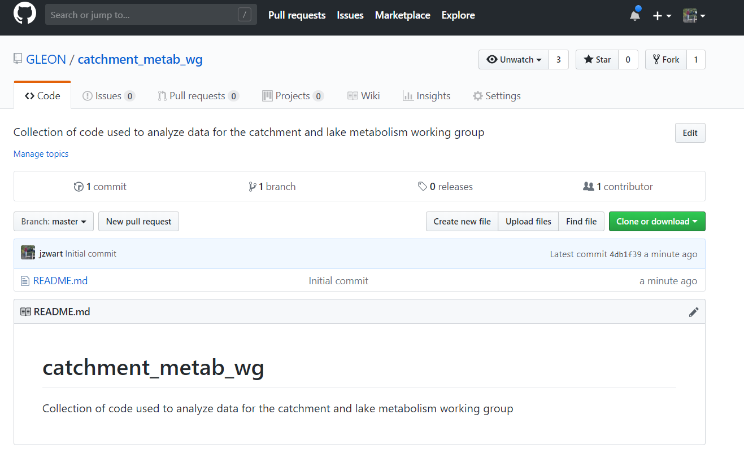Navigate to the [repository](https://github.com/GLEON/catchment_metab_wg) in the GLEON organization.
3. 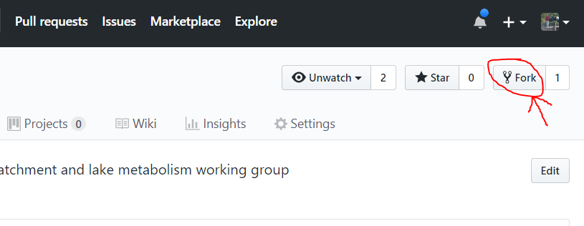Fork the catchment_metab_wg repository to your own Github account
4. 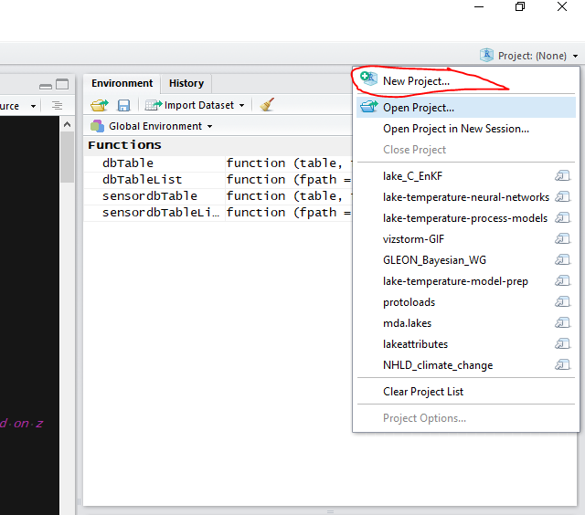Open RStudio and click on the *Project* pull down tab. Select *New Project…*
5. 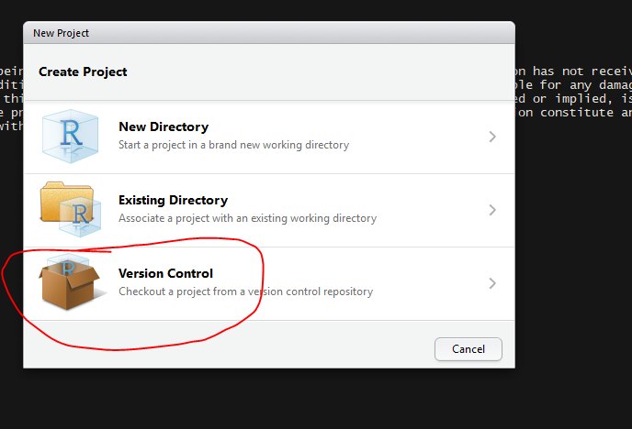Select *Version Control*
6. 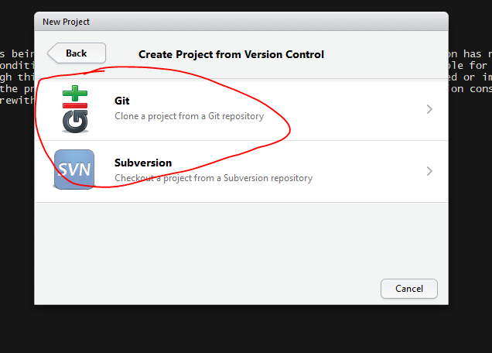Select *Git*
7. 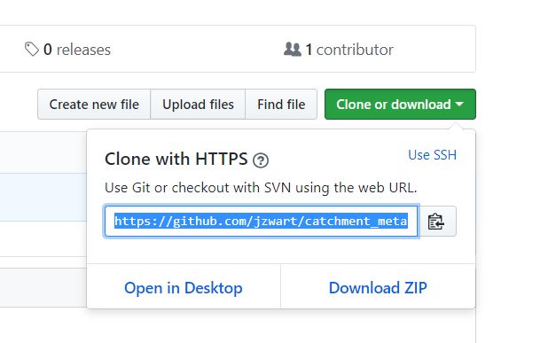Now you need to download your remote repository to your local computer. You will make changes on your local files and push them up to the remote repository. To download, navigate to your forked repository and click “Clone or download” and copy the URL
8. 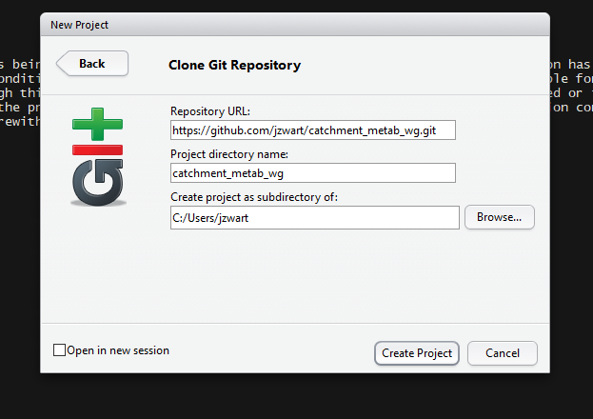Paste the URL in the new project’s *Repository URL*; the directory name should automatically populate. Click ‘Create Project’. All the files on the Github repository will download to your local computer.
9. Start Coding! When you make changes to a file or group of files and you want other people working on the repository aware of you changes, you need to:
   1. *Commit* your changed files,
   2. *Push* your commit up to your remote repository (your forked repo on you own github account), and
   3. create a *Pull Request* for a group of commits that you want to be merged into the main repository on the GLEON organization github repository.

More details on these steps below.

1. 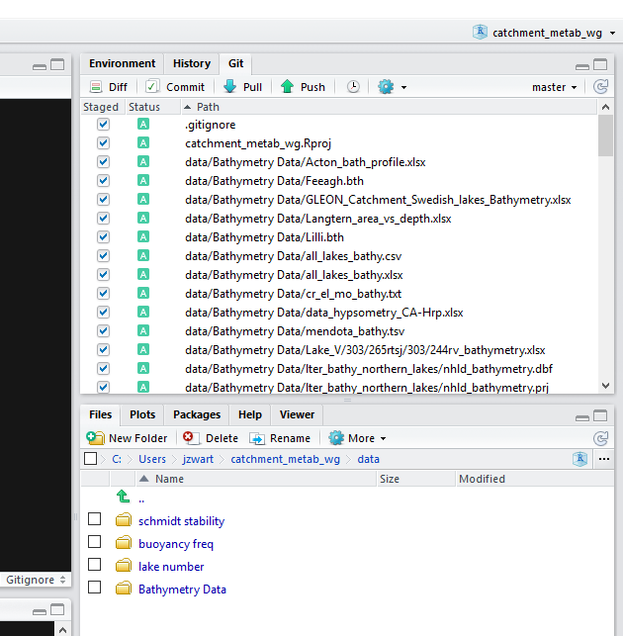When you have made changes to files locally, navigate to the *Git* tab in RStudio and check the files you want to Commit.
2. 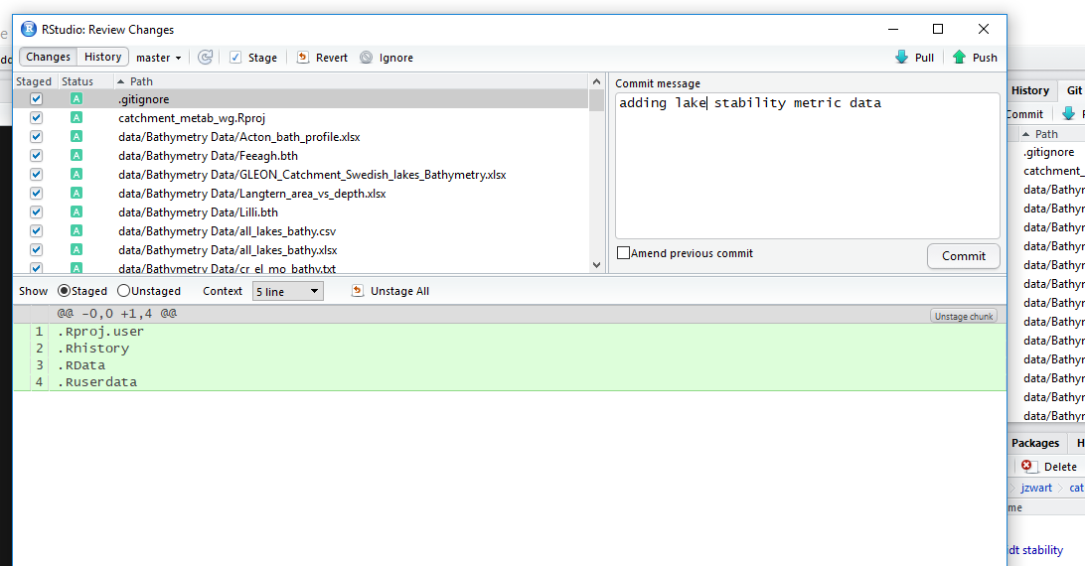Add a commit message about your file changes
3. 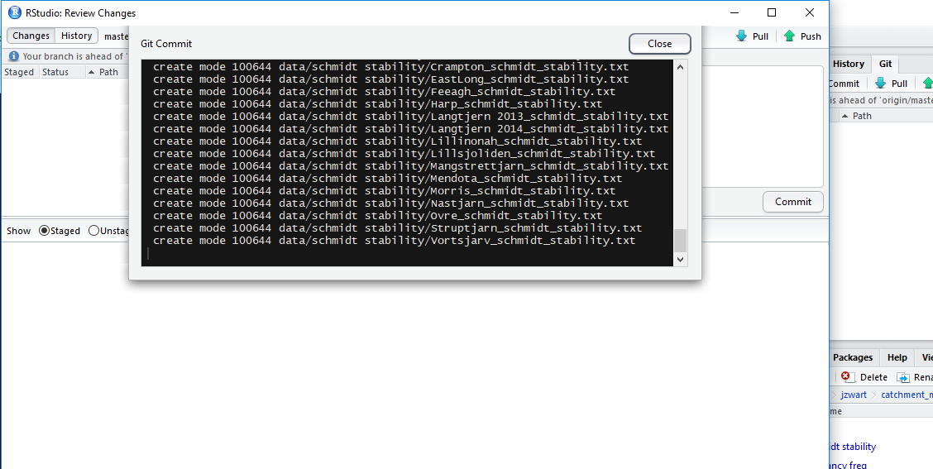Press *Commit*
4. 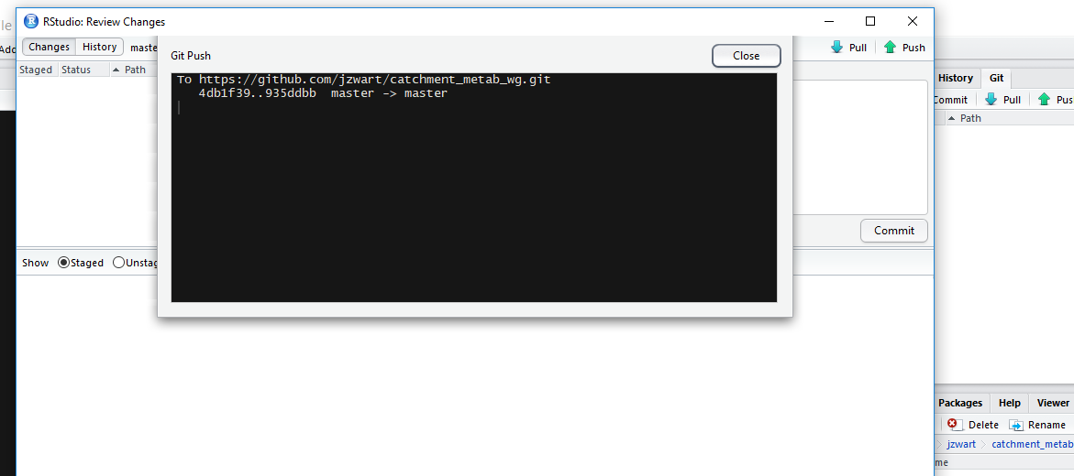*Push* your committed files up to your remote repository (this will be on your github account
5. 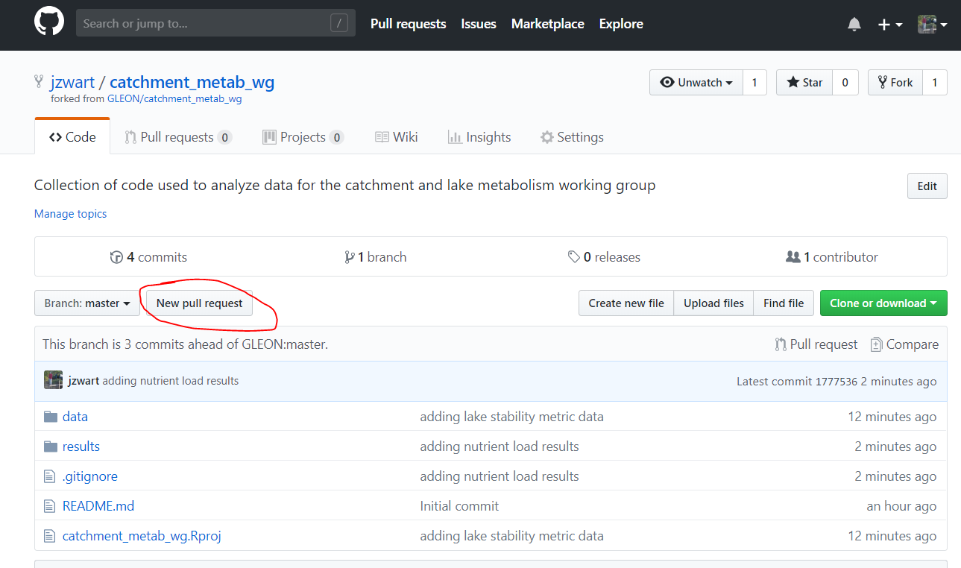When you have made commits that you want to be merged into the main ‘upstream’ repository (the GLEON repo), you need to create a *Pull Request* from your remote repository to the GLEON repository. Navigate to your remote forked repository and select *New pull request*
6. 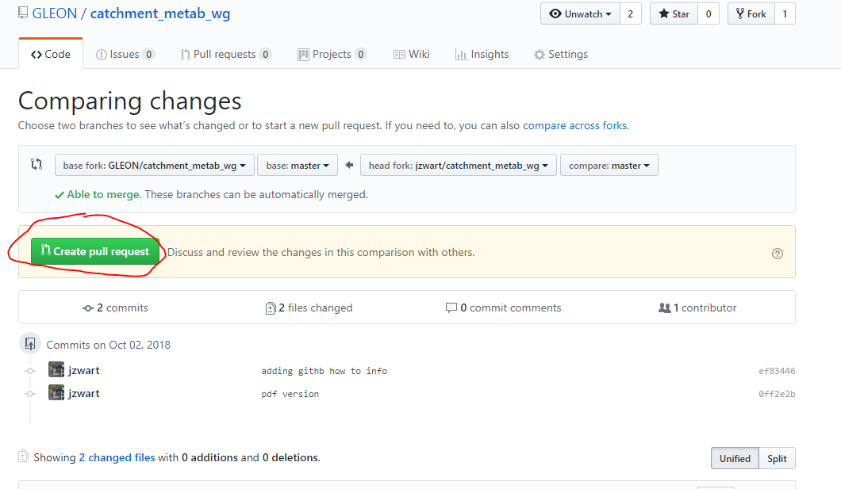If your branch of the repository can merge into the base fork, click *Create pull request*
7. 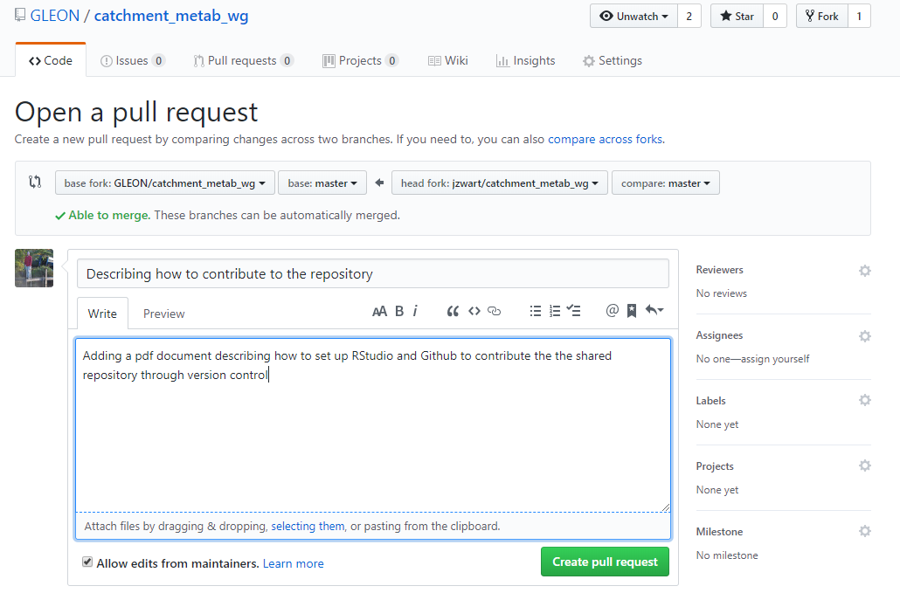Add a description of what your pull request will change in the main repository
8. That’s it! If you want to specify a reviewer of your PR (Pull Request) then you can do that, otherwise someone will look over your changes and either *merge* your changes into the main repository or ask for some changes /updates to your local files. If you’re asked to make changes before the PR can be merged, simply make changes to your files locally, *commit*, and *push* and the new changes will be incorporated into the open PR.
9. 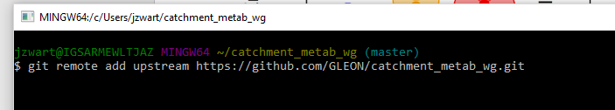If someone has made changes to the upstream repository (GLEON repo), then you need to *Pull* those changes down to your local branch on your computer. You first need to tell RStudio where the upstream repository is located. To do this, in RStudio navigate to *Tools* => *Shell…* and then add the upstream repository using the following code:

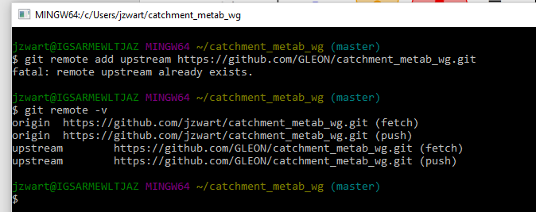Check if the upstream repo is added, use the following code:

1. 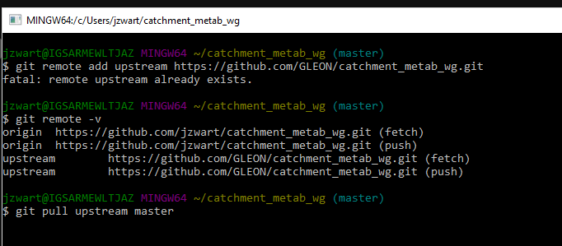To incorporate remote changes on the upstream repo into your local repository, use the following code:

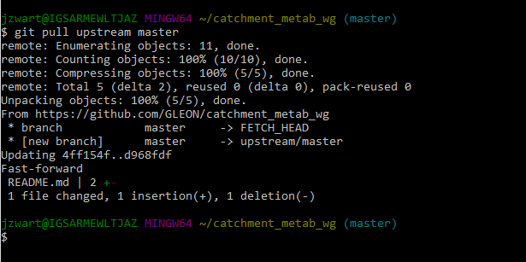If there are changes upstream that were incorporated into your local branch, you’ll get something like this:

If you’re already up-to-date, then you’ll get this message:

